Evidence-based Dental Pain Care: A New Opioid Prescribing Guideline from Washington State

Date: April 19 and 20, 2018

Time: Registration 7:30 am to 8:30 am Conference 8:30 am to 12:30 pm

Locations:

April 19, 2018
Northern Quest Resort
100 N Hayford Rd
Airway Heights, WA 99001

April 20, 2018
UW Alder Commons Auditorium
1315 NE Campus Parkway
Seattle, WA 98195

Agenda

Min | Time | Time & Lead | Topic
15 | 8:30 | DBHR and L&I | Welcome and Objectives
45 | 8:45 | Gary Franklin, MD, MPH | The Opioid Epidemic: Overview and a Look to the Future
60 | 9:30 | Omar Abubaker, DMD, PhD | Addressing the Opioid Crisis: A National Perspective on Dental Care
15 | 10:30 |  | Break
30 | 10:45 | Rolf Christensen, DDS | Highlights of the 2017 Bree/AMDG Dental Guideline on Prescribing Opioids for Acute Pain Management
60 | 11:15 | Omar Abubaker, DMD, PhD – Moderator  Amy Cook, DDS  Rolf Christensen, DDS  Theresa Madden, DDS, MS, PhD | Panel:  NPR – WHYY Radio – James’ Story  Lessons from the Front Line – Managing Acute Dental Pain in Various Practice Settings  - How dentists can help mitigate the opioid epidemic  - How the guideline is used in managing acute pain  - How to integrate PMP into your practice workflow, triggers for checking the PMP
15 | 12:15 | DBHR and L&I | Summary and Closing Remarks
 | 12:30 | Adjourn

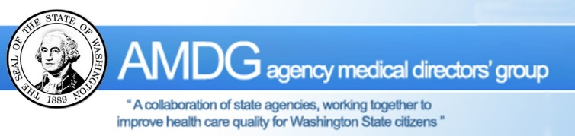
All participants will receive up to 4 hours of free dental CE, a copy of the 2017 Bree/AMDG Dental Guidelines on Prescribing Opioids for Acute Pain Management and a one-page summary of the guideline!

